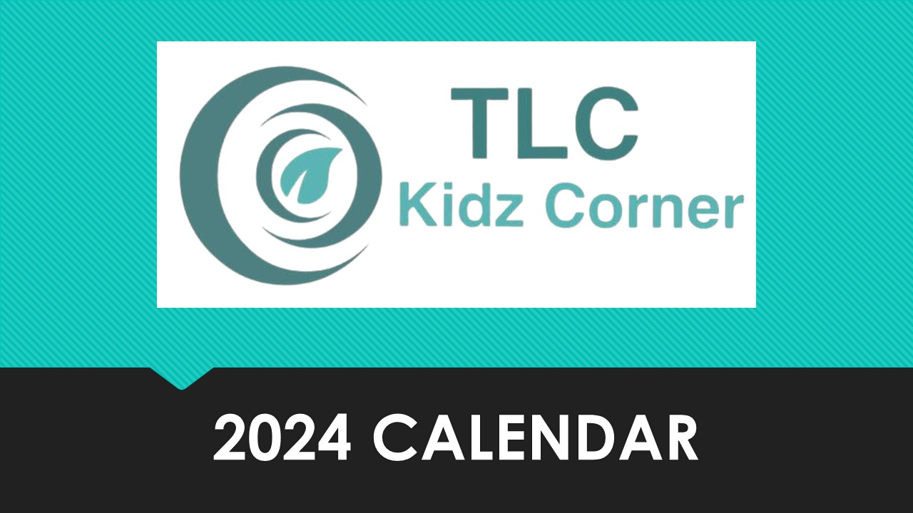

January

February
- February 11th During Service
  - Cereal Bowl Sunday
    - Come prepared to play some fun cereal themed games!
    - Enjoy some cereal in a real bowl that morning.
March
- March 30th^{th} from 11:00 am-12:30 pm
- Easter Egg Hunt
    - Join us for an Easter Egg Hunt and a short Bible lesson & light lunch.
April
- April 21st from 10:00 am-2:00 pm
- Kids Service Project & Lunch
  - Kids will fill bags for teachers and eat lunch together.

May
- May 26th from 11:30 am-2:00 pm
  - Schools Out Celebration
    - We will be celebrating the end of school with lunch, ice cream & games
June
- June 9th from 11:30 am-2:00 pm
  - Family Lego Build Day
    - Families will join us after service for lunch and fun day of building with Legos
July
- July 21st-25th
  - SCUBA VBS
    - Kids will learn about how we Shine Jesus’ Light. We will sing songs, learn a Bible lesson, play games, eat snacks and visit Imagination Station. Our last night will conclude with our carnival.
August
- August 18th from 8:00 am-10:00 am
  - Pajamas & Pancakes
    - Parents and kids are invited to join us for pancakes. Be sure to wear your pj’s.
Septemeber
- September 22nd from 11:30 am-2:00 pm
  - Make a Movie Party
    - Join us as we have fun making our own mini movies! Lunch will be served.
October
- TBD
  - Trunk or Treat
    - Be sure to dress up in your costume and join us for Trunk or Treat
November
- November 9th from 5:30 pm-8:30 pm
  - Operation Christmas Child Packing Party & Dinner
    - We will pack boxes for Operation Christmas Child and eat dinner together. All welcome!
December
- December 8th from 11:30 am-2:00 pm
  - Kids Christmas Party & Lunch
    - We will eat lunch, have a White Elephant style gift exchange, and play games.

For questions on event be sure to contact Angie Mckibben at 513-479-1460 or email Angie @ angie@truelifecc.com

